Lesson Plan Coding System

As you prepare to teach a Springboard Collaborative Early Literacy Curriculum lesson, consider using this Lesson Plan Coding System to help you effectively and efficiently prepare and internalize the lessons. Follow these steps:
- Find, download, and open the lesson plan (if preferred, print a hard copy).
- Read through the lesson plan in its entirety one time through; pay close attention to the skills, goals, and flow of the lesson (including the “Say” or “Do” student and teacher actions).
- Re-read the lesson plan and add the following codes (found in the table below) directly into the lesson plan; adding these codes will help you identify action items that should be addressed before teaching the lesson.

In addition to the coding system, consider using the following questions to help guide your preparation:
- Are there specific areas that you think students will need additional support?
- Are there any portions of the lesson plan you’ll want to practice before you teach it? Consider practicing it now!
- Do you have all of the materials you need to teach the lesson? Find them and bookmark them!

Lesson Plan Coding System
PM  (Prepare Material) | This code represents a section of the lesson that requires material to be prepared in advance. This would include things such as: Elkonin boxes, Letter mats, Student/Teacher Resource Books, etc. You will want to have these items prepared (either printed or projected, depending on the resource) in advance of teaching your lesson. | 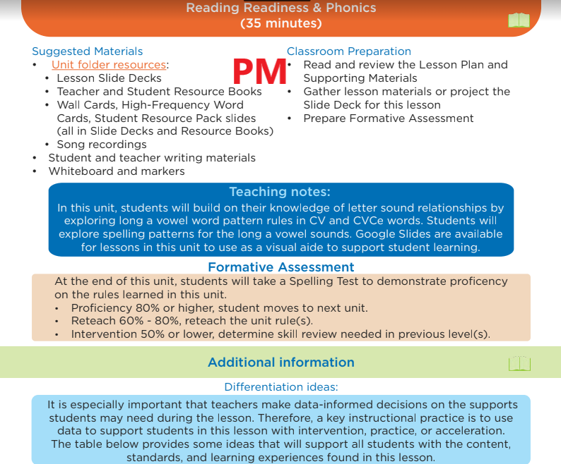
PL  (Practice Lesson) | This code represents a portion of the lesson you’ll want to practice in advance of working with your students. This might be new content, a tricky skill or concept, or an area your students have struggled with before. Consider role-playing with a colleague and soliciting feedback before working with your students. | 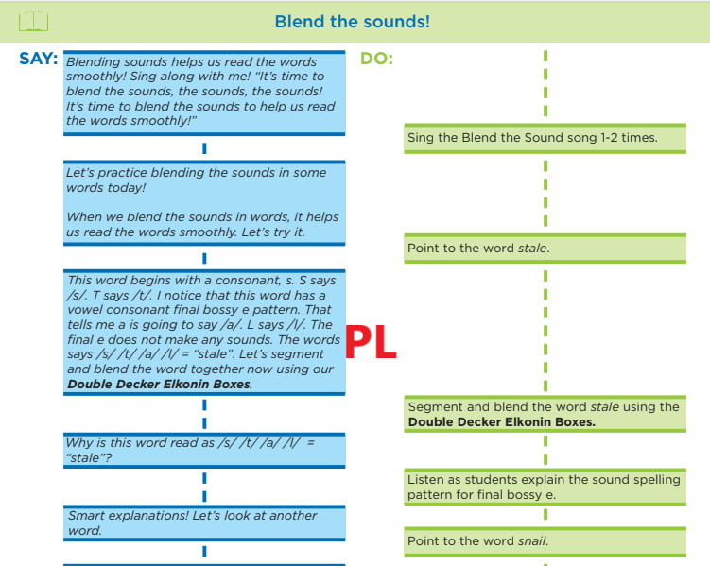
NC  (New Content) | This code represents when a new skill or strategy is introduced. Pay close attention to these sections, including the phonics rule and pronunciation guidance, as you’ll want to ensure you are comfortable presenting this information to your students. | 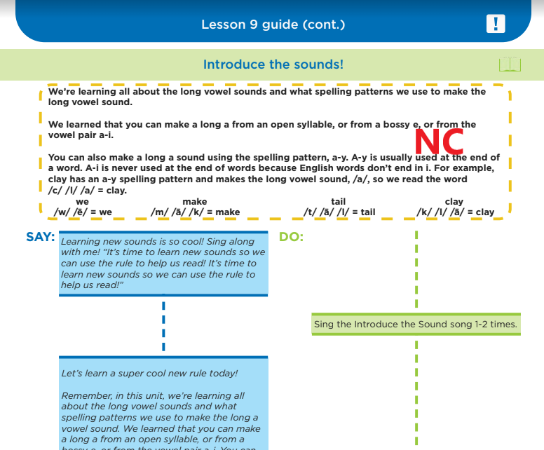
M&A  (Monitor and Adjust) | This code represents a place in the lesson you might consider pausing and checking in with students: are they comprehending the content so far? Do you need to adjust your instruction? Be sure to use the “Correction Routine” to guide students who encounter misunderstandings or misconceptions. | 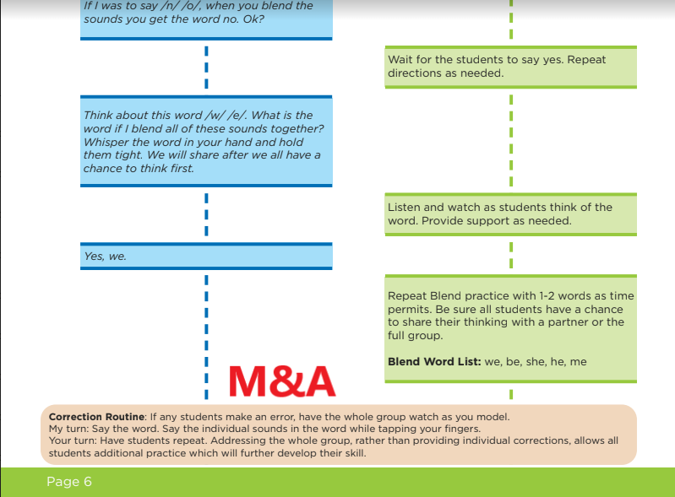
FA  (Formative Assessment) | This code represents the place in the lesson and/or unit plan where you’ll conduct an official formative assessment (in addition to any informal checking for understanding discussed above). Be sure to prepare in advance any directions, student print-outs, scoring guidance, etc. | 