Data-Driven Instructional Protocol (DIBELS)

Data-driven instruction helps educators make informed decisions about the practices that will support student learning.

The purpose of this data-driven process is to highlight ways leaders and teachers can analyze student data to help determine:
- Students’ strengths
- Students’ areas of improvement
- Students’ learning focus moving forward
- Best practices needed to support students’ learning

The following data-driven instructional protocol can be used with any assessment data. This protocol is meant to be a part of a larger continuous improvement cycle where data is explored and reviewed multiple times throughout learning to increase student impact. In this sample detailed agenda, we will be using DIBELS data for the think aloud example.

Data-Driven Instructional Protocol

Step 1: Look at the assessment data and results
Step 2: Review and analyze data for one student at a time
Step 3: Determine the areas of strength
Step 4: Determine the areas of improvement
Step 5: Determine the learning focus moving forward (this will ultimately support the student’s pre-determined growth and stretch goals)
Step 6: Determine the instructional strategies and practices that will best support the learning focus
Step 7: Create 1-3 action steps that will support this student
Step 8: Group students with a similar learning focus

Data-Driven Instructional Protocol Think Aloud

The purpose of this think aloud example is to provide facilitators of the PLC with an example to model for teachers of the data-driven instructional protocol before teachers use the protocol to analyze their own student data.

Step | Example
Step 1:  Look at the assessment data and results | 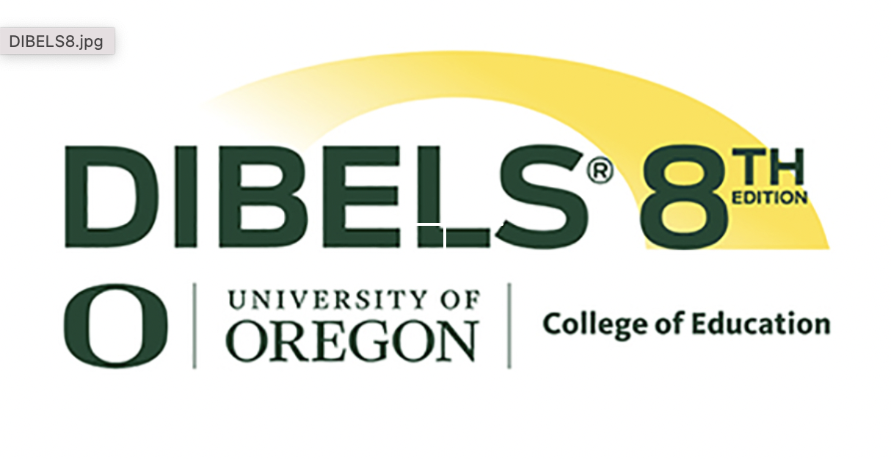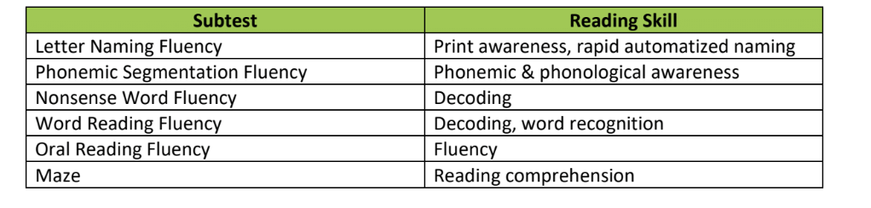  Review the assessment for your curriculum/grade level(s). Determine the DIBELS subtest assessment data you would like to take a deeper look at today.
Step 2:  Review and analyze data for one student at a time | The student is in Kindergarten (or Springboard Collaborative’s Curriculum Level A classroom) and took the Nonsense Word Fluency (NWF) subtest.  NOTE: Although more than one subtest can be administered to a student, Springboard Collaborative only requires one subtest for each grade: Pre-K: PSF, K-3: NWF, 4+-ORF. It is possible teachers come to the PLC with additional subtests; if this is the case, they are encouraged to use the same data-driven protocol to analyze data from other DIBELS subtests.  The student’s data on the required subtest is:  - Nonsense Word Fluency (NWF): 6 sounds correct, 3 words correct  The data shows that the student is able to read 3 words and identify 6 sounds.
Step 3:  Determine the area of strength | The NWF data shows that the student is just starting to identify sounds in printed words and blend the sounds together.  These are huge steps in the reading development process and are something to celebrate and highlight!
Step 4:  Determine the area of improvement | The NWF data suggests that the student also needs support with connecting letter sounds to printed letters (letter-sound correspondence) and blending those sounds to read words.
Step 5:  Determine the learning focus | Since the student is already starting to make letter-sound connections by reading 3 words, it is important to continue to support this letter-sound connection knowledge development while also supporting the students' understanding of specific letter-sound connections.  Therefore, this student’s learning focus moving forward should be:  - I can connect the sounds I hear in words to the letters I see in order to read more words.  For information on the subtests that contribute to students’ growth and stretch goals, please see the document titled Using DIBELS with Springboard Collaborative.
Step 6:  Determine the instructional strategies and practices that will best support the learning focus | Since the student’s learning focus moving forward is to connect the sounds and letters, this student will benefit from the following instructional practices:  - Rhyming and alliteration (poems, riddles, and repeated readings)  - Onset and rime practice  - Phoneme segmentation and blending (hearing words and changing them)  - Alphabet (song, movement, and visuals that help make sound-letter connections)
Step 7:  Create 1-3 action steps that will support this student | Reflect on the next steps you will need to complete as a teacher to support this student and other students in your class. Here are a few possible next steps for this example.  - Organize (additional) materials for whole group and/or small group literacy instruction  - Articulatory gestures chart  - List of words for phoneme segmentation/blending  - Poems and riddles  - Decodable text  - Practice facilitating instruction
Step 8:  Student grouping | Finish data analysis for all students and place students with similar strengths and areas of improvement in flexible groups. If your instruction is mostly whole group, use the data to determine students’ starting points and lesson adjustments using the Using DIBELS Data to Drive Instruction guidance.

Data-Driven Instructional Protocol (Teacher Planning Sheet)

Step | Notes
Step 1:
Look at the assessment data and results
Step 2:
Review and analyze data for one student at a time
Step 3:
Determine the area of strength
Step 4:
Determine the area of improvement
Step 5:
Determine the learning focus

Step 6:
Determine the instructional strategies and practices that will best support the learning focus
Step 7:
Create 1-3 action steps that will support this student
Step 8:
Student grouping

