Learning Bonus Celebration Sample Documents

Prior to the Learning Bonus Celebration, all families should receive:
Save the date: Samples found on the resource site. Send at least two weeks before the celebration.  Invitation: Samples found on the resource site. Send the week before the celebration.  - Note: Save the dates and invitations can be creative. Ask students to write their own personal note inviting their family members! Use www.canva.com or evite programs  Reminder: A quick text the week of the celebration. | 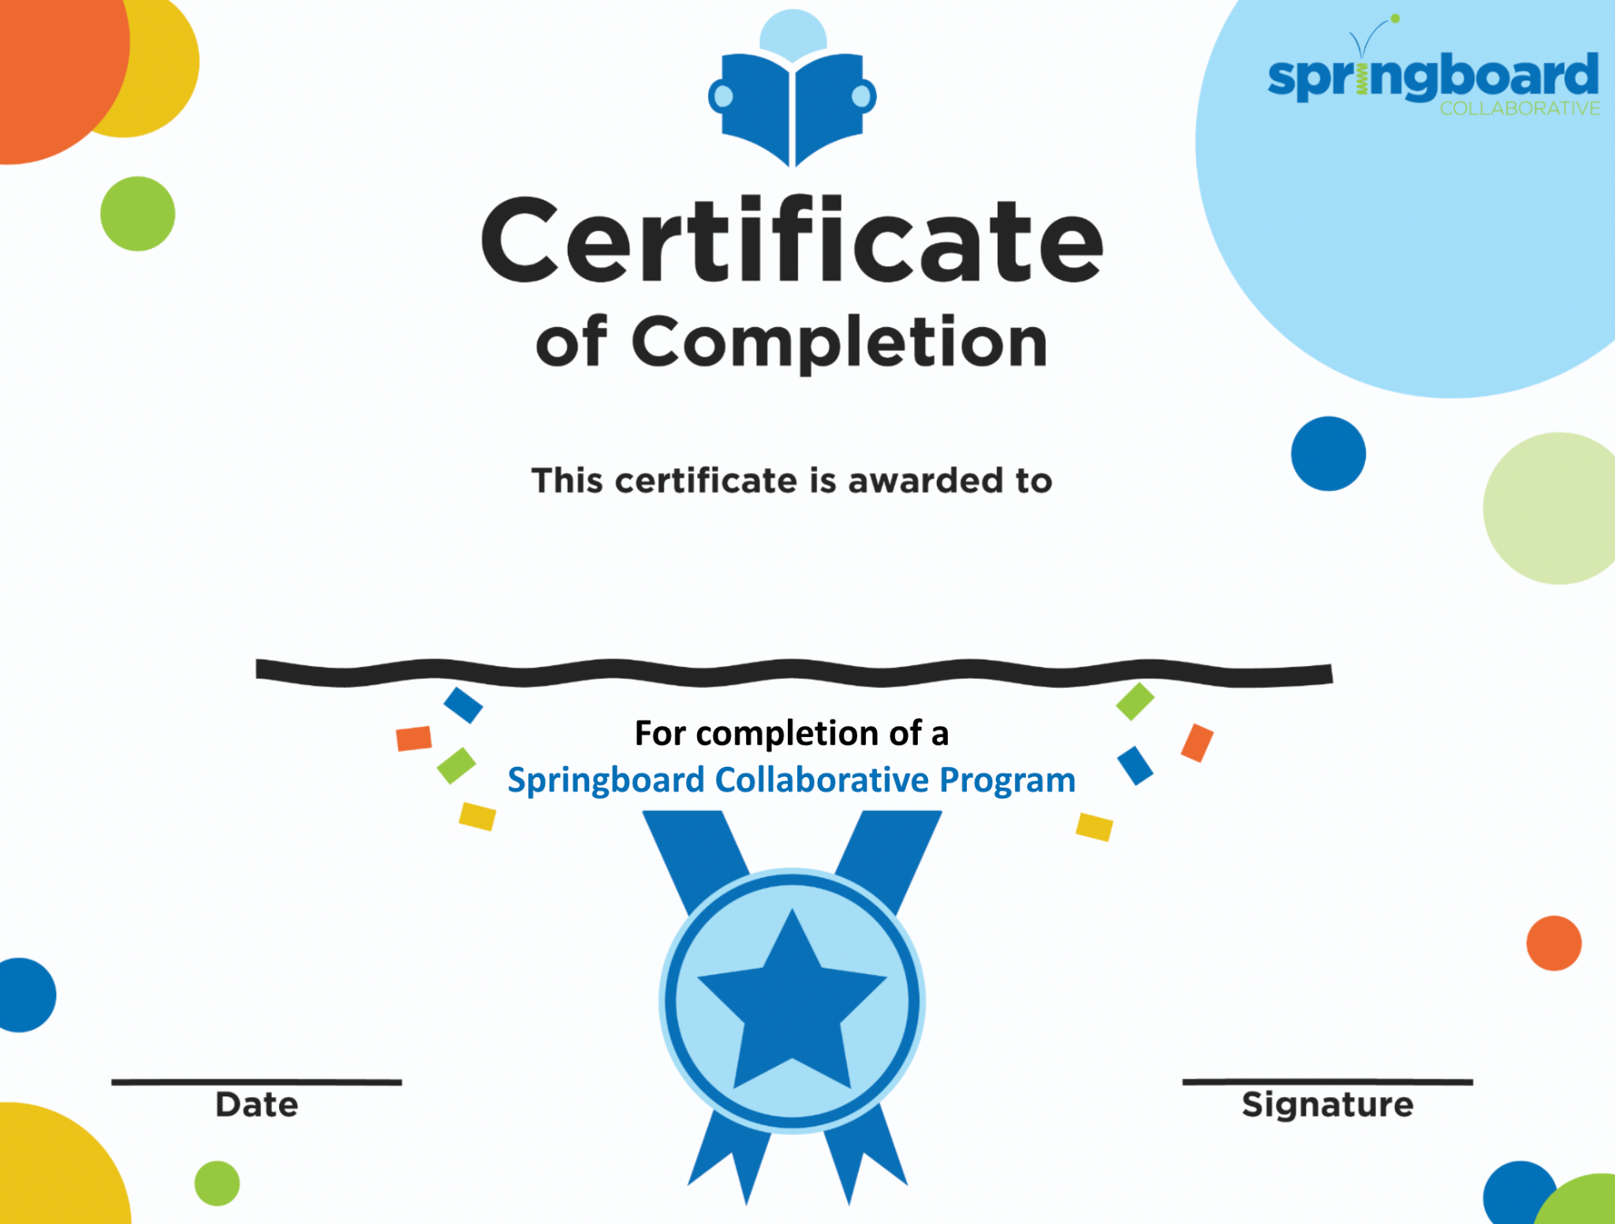
Reward letter: a letter that details the family’s participation, the students’ reading ability, and the rewards that are earned. Be sure to send this after the assessments have been verified.  - Note: Award Letters can be downloaded and printed through Connect. | 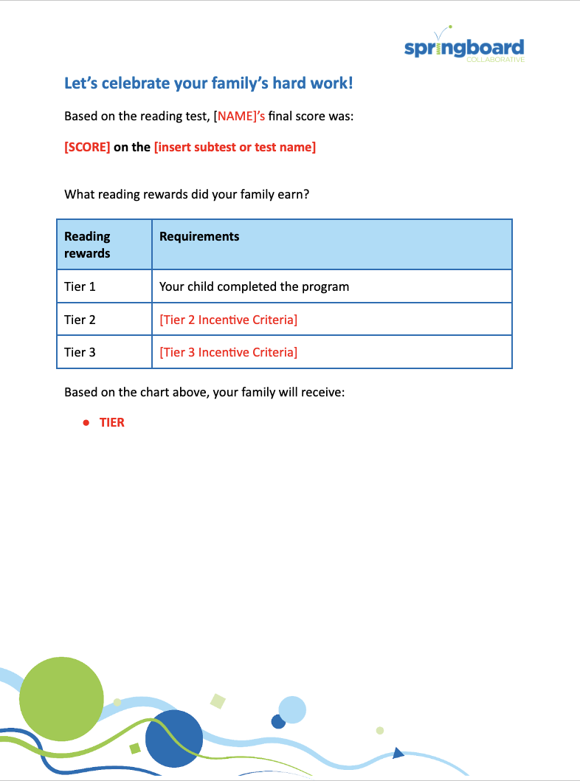
At the Learning Bonus Celebration, students should receive:
Certificate: Every student receives a personalized certificate. Family certificates are also available for adult family members.  Attendance Certificate: Additional certificates can be awarded for students with perfect daily attendance. | 