Growth Goals

There are many ways to measure reading growth, thus a number of different ways for setting measurable reading goals. In order to know where we are going, we must first know where we are starting. At Springboard Collaborative, this is how we look at **reading goals for students.** No matter where a student starts, pinpointing a specific and individualized reading goal enables every person in the child’s life to invest in their literacy life. Family, neighbor, teacher, leader and student can all rally behind the goal for the duration of the program which will increase the student’s likelihood of reaching it.

Springboard Collaborative’s primary way of tracking students’ goal attainment and progress toward grade-level reading development from the start to the end of a Springboard Collaborative session is through setting **assessment-based growth goals** for students. For partners that prefer a behavioral-based goal we also accommodate this type in the form of **reading practice targets**.

**Assessment-Based Goals**

**Determine the “Starting Location” and Growth Goal**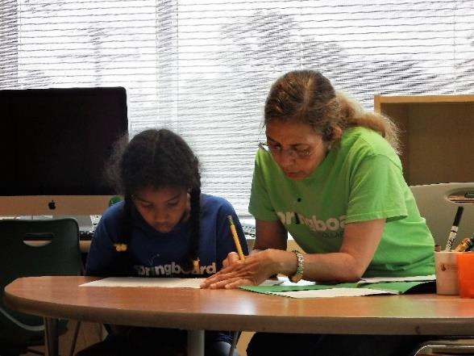

Assessing a student’s literacy skills is one way to measure reading growth and also the best way to identify a student’s current level of reading performance. At Springboard Collaborative, DIBELS 8th is the assessment used to determine the student’s beginning level and set assessment-based goals. At Springboard Collaborative, we like to think ambitiously and set the bar high when setting appropriate growth goals. Goals for DIBELS 8th are dependent on the length of programming and amount of instruction students receive.

When a student meets their assessment-based goal, it means they grew in the skill(s) that were measured by that assessment. For example, if an assessment measures the skill of phonemic segmentation (breaking apart the sounds in words) and the student reaches their goal, then we can be confident that the student grew in their ability to break apart sounds in words. Likewise, if the assessment measures fluency and the student meets their goal, then we can be confident that the student improved their fluency.

Goals are intended to be both ambitious yet achievable for students. Students’ confidence in reaching a goal is largely influenced by the adults in their lives and their belief that they can reach it.

**Stretch Goals for Assessments**

Some sites use stretch goals in addition to growth goals. A stretch goal can be achieved with hard work, dedication, and collaboration. Circling back to the metaphor of using the starting location to determine a growth goal, the stretch goal would be one step beyond the growth goal. For assessments, it’s another level past their growth goal target. At Springboard Collaborative, we distinguish stretch goals from growth goals in order to motivate and recognize exceptional progress.

**Individualized Education Program (IEPs)**

Students enrolled in Springboard Collaborative programming may have an Individualized Education Program (IEP). Every IEP is unique and outlines accommodations that allow students to access the equitable educational opportunities. When in doubt, always look to the IEP and the school’s special education policies to make decisions about IEP accommodations. At Springboard Collaborative, the general rule of thumb is to require students with IEPs to *maintain* their current reading score over the course of the program. This is their assessment-based growth goal. For example, if a student scored a 34 on the beginning assessment, their growth goal is to maintain that score by the end of programming. If the student showed growth by, for example, scoring 40, they would have reached their stretch goal, if applicable. The purpose of this guidance is meant to make reaching goals equitable and achievable for students with IEPs. Goals and learning targets for students with IEPs should always consider the student-specific information in the IEP and ensure that the student is being supported to reach their fullest potential.

**Springboard Collaborative and DIBELS 8th**

Growth and stretch goals are provided for Springboard’s supported assessment, DIBELS 8th. Connect: Educator will automatically generate goals for DIBELS 8th, and Springboard Collaborative will provide training on how to use it within our programming. See the document titled *Using DIBELS with Springboard Collaborative* on the program resource site for more information.

**Reading Practice Targets**

Sites that plan to use an assessment not supported by Springboard (i.e., an assessment other than DIBELS 8th) will use reading practice targets to set programmatic goals and, if applicable, determine rewards. Assessment data will be sent to Springboard Collaborative for the purpose of reporting on impact.

For sites that plan on using reading practice targets (i.e., not an assessment to set goals), students will read either a certain amount of books or for a certain amount of time over the course of programming. Students will work toward **expected reading targets** and **exceeded reading targets** (select sites only). The exceeded target (select sites only) is an amount beyond the expected target. For more information, see the document titled *Using Reading Practice Targets with Springboard Collaborative* on the program resource site.