**PLEASE READ**: The following templates are to use in recruiting families for enrollment. There is

* a longer email template that is more informative and visual
* a shorter email template
* texting templates
* blurb for a newsletter
* an email template to ask teachers to help you identify and recruit families

Note: all highlighted brackets must be edited for each individual school’s programming prior to sending out to families. You must also insert a link to your specific site’s enrollment link.

Images & formatting have been tested for reading emails on laptops and phones.

# LONGER/MORE INFORMATIVE Family outreach email template

*Directions: Copy & paste template, and edit all highlighted brackets for school-specific information. Please insert your site’s specific enrollment link into the “ENROLL NOW” green button.*

**ENGLISH**

[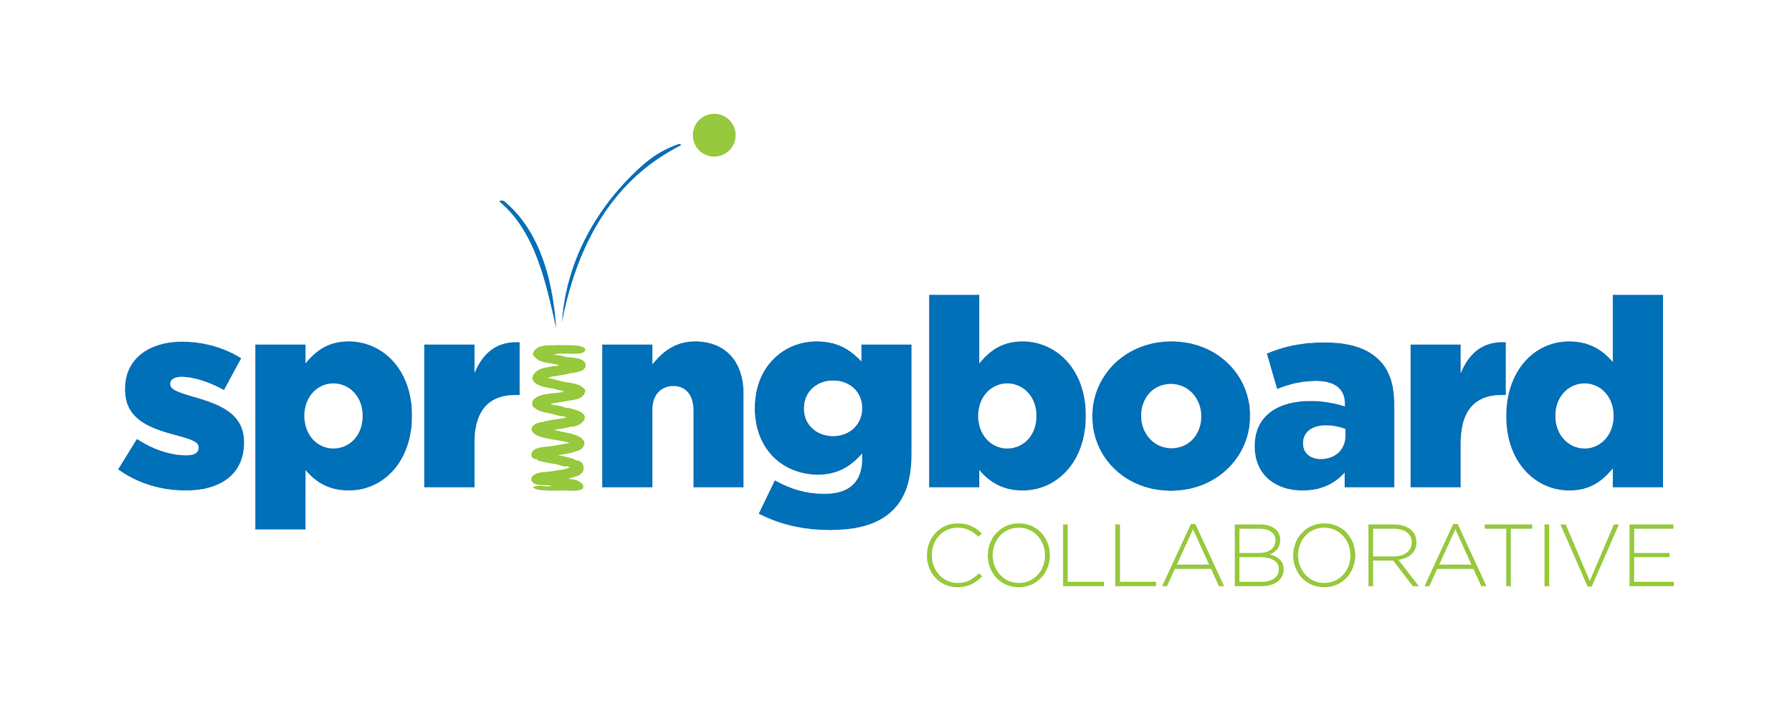](https://www.springboardcollaborative.org/sla/)

Hello [insert family member name],

I am reaching out to invite you and [child’s name] to a [5-10]-week literacy accelerator program! Our school has partnered with [**Springboard Collaborative**](https://www.springboardcollaborative.org/) to bring this literacy program to our school and it’s **free** to our families.

I believe this would be a great opportunity for us to work together to help your young reader’s reading growth: I’ll be working closer with them through instruction and you and [child’s name] will attend Family Workshops to learn new ways to read at home.

**Programming is from** [start month/date] **to** [end month/date]:

* [Child’s name] attends instruction with me on [week dates] at [times]
* You and [child’s name] will attend [4] Family Workshops on [4 dates]
* You and [child’s name] will practice at home nightly and if you want, can track your reading in an app!
* [Child’s name] will have a reading goal and if they reach it, they can earn reading rewards!

Enrollment in the program is really easy! Click the following button:



Here is an overview of the **Springboard Journey**:

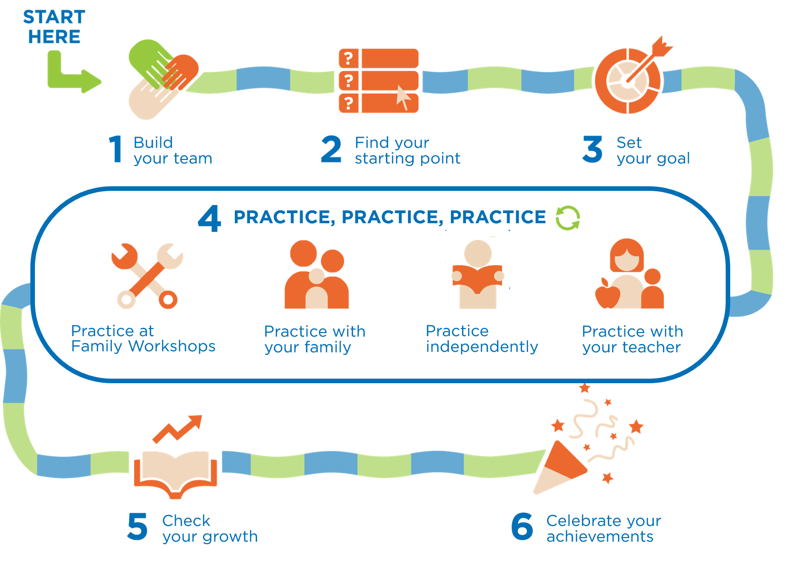

You can also watch a family introduction video to the program in [English here](http://bit.ly/%203uLUMwu) and in [Spanish here.](http://bit.ly/3iYCB4b)

If you’d like to discuss the program, feel free to reach out to me by [method].

Hope to hear from you soon,

[Your name]

**SPANISH**

Hola [insert family member name],

Me estoy comunicando para invitarlos a usted y a [child’s name] a un programa acelerador de alfabetización de 5-10] semanas. Nuestra escuela se ha asociado con [**Springboard Collaborative**](https://www.springboardcollaborative.org/) para implementar este programa de alfabetización en nuestra escuela y es **gratis** para nuestras familias.

Creo que esta sería una gran oportunidad para trabajar juntos para ayudar a su joven lector a crecer en su lectura: Yo estaré trabajando atentamente con él o ella por medio de instrucción y usted y [child’s name] estarán asistiendo a los talleres familiares para aprender nuevas maneras de leer en casa.

**El Programa es de** [start month/date] **a**  [end month/date]:

* [child's name] tendrá instrucción conmigo los [week dates] a [times]
* Usted y [child's name] estará asistiendo a 4 talleres familiares: [4 dates]
* Usted y [child's name] practicarán en casa cada noche y si quieren, pueden monitorear su lectura en una aplicación!
* [Child’s name] tendrá una meta de lectura y si la logra, puede ganar premios de lectura!

Inscribirse en el programa es muy fácil! Haga clic en el botón que sigue:



Aquí hay una descripción general del **Springboard Accelerator Journey**:

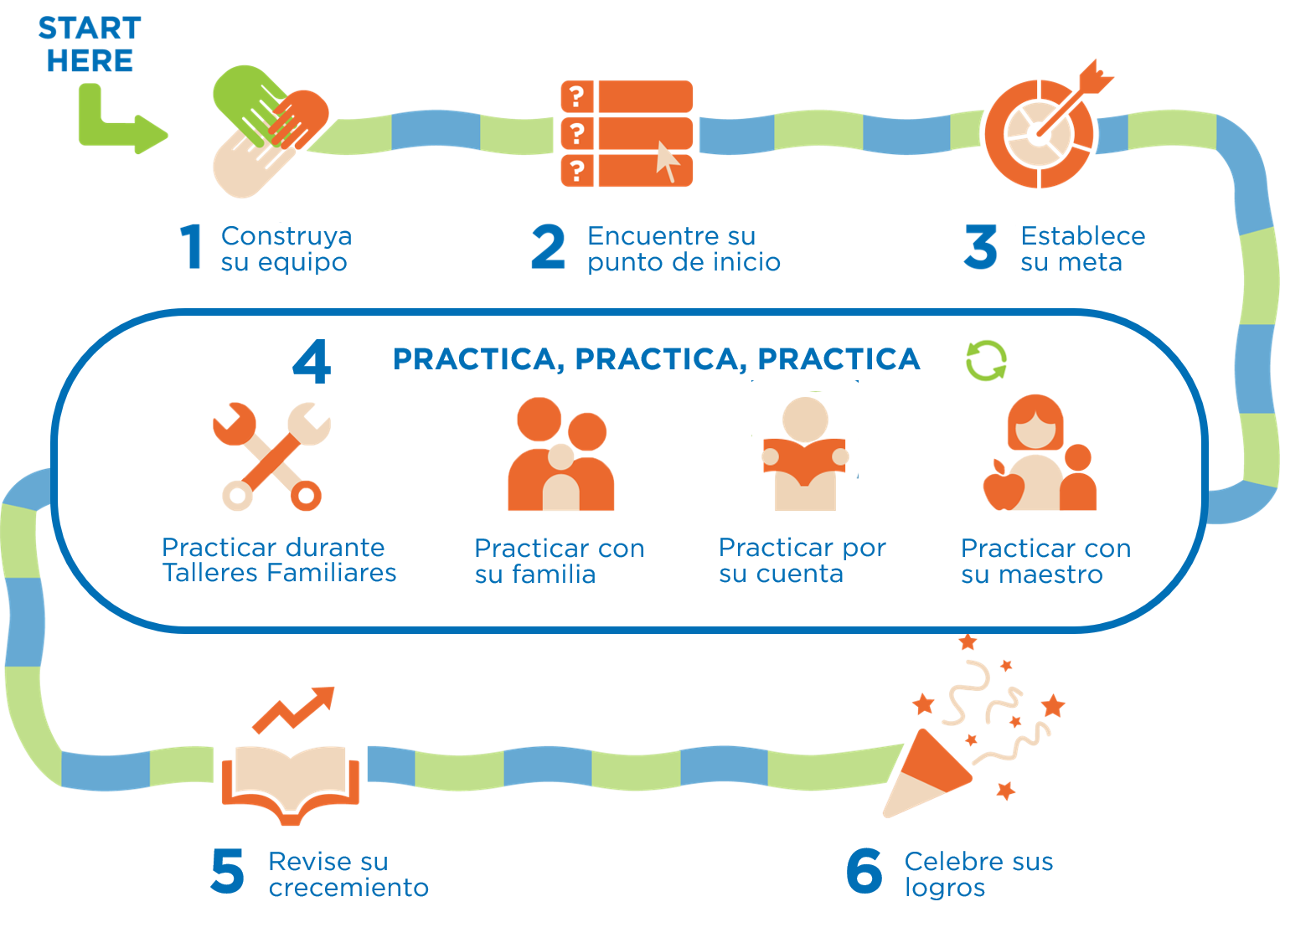

También pueden ver un vídeo familiar de introducción al programa en [Inglés aquí](http://bit.ly/3uLUMwu) y en [Español aquí.](http://bit.ly/3iYCB4b)

Si quisiera discutir algo sobre el programa, no dude en contactarme por [method].

Esperamos escuchar pronto de usted,

[Your name]

# SHORTER/LESS INFORMATIVE Family outreach email template

*Directions: Copy & paste template, and edit all highlighted brackets for school-specific information.*

**ENGLISH**

[**](https://www.springboardcollaborative.org/sla/)

Hello [insert family member name],

I am reaching out to invite you and [child’s name] to a [5-10]-week literacy accelerator! Our school has partnered with [**Springboard Collaborative**](https://www.springboardcollaborative.org/) to bring this literacy program to our school and it’s **free** to our families.

**Programming is from** [start month/date] **to** [end month/date]:

* [Child’s name] attends instruction with me on [week dates] at [times]
* You and [child’s name] will attend 4 Family Workshops on [4 dates]
* You and [child’s name] will practice at home nightly

Enrolling in the program is really easy! [Click here] to enroll. You can also watch a family introduction video to the program in [English here](http://bit.ly/3uLUMwu) and in [Spanish here](http://bit.ly/3iYCB4b).

If you’d like to discuss the program, feel free to reach out to me by [method].

Hope to hear from you soon,

[Your name]

**SPANISH**

[**](https://www.springboardcollaborative.org/sla/)

Hola [insert family member name],

Me estoy comunicando para invitarlos a usted y a [child’s name] a un acelerador de alfabetización de 5-10] semanas.Nuestras escuelas se han asociado con [**Springboard Collaborative**](https://www.springboardcollaborative.org/) para traer este programa de alfabetización a nuestra escuela y es **gratis** para nuestras familias.

**El Programa es de** [start month/date] **a** [end month/date]:

* [child's name] tendrá instrucción conmigo los [week dates] a las [times]
* Usted y [child's name] asistirán a 4 talleres familiares: [4 dates]
* Usted y [child's name] practicarán en casa por las tardes

¡La matrícula es muy fácil! [Haga clic aquí] para inscribirse. También pueden ver un vídeo familiar de introducción al programa en [Inglés aquí](http://bit.ly/3uLUMwu) y en [Español aquí.](http://bit.ly/3iYCB4b)

Si quisiera discutir algo sobre el programa, no dude en contactarme por [method].

Esperamos escuchar pronto de usted,

[Your name]

# SHORT Family outreach text template

*Directions: Copy & paste template, and edit all highlighted brackets for school-specific information.*

**ENGLISH**

You and [child’s name] have a spot reserved in a [5-10]-week reading accelerator program with **Springboard**! This program helps children develop reading confidence, reach reading goals and is free for families at [name of school or org].

**Program** starts [ month/date] and ends [month/date]:

* [Child’s name] attends instruction with me on [week dates] at [times]
* You and [child’s name] will attend 4 Family Workshops on [4 dates]
* You and [child’s name] will practice at home nightly

Enrolling in the program is really easy! [Click here] to enroll. You can also watch a family introduction video to the program in [English here](http://bit.ly/3uLUMwu) and in [Spanish here](http://bit.ly/3iYCB4b).

**SPANISH**

¡Usted y [child's name] tienen un lugar reservado en un programa acelerador de lectura para [5-10]- semanas con **Springboard!** Este programa ayuda a los niños a desarrollar la confianza en la lectura, alcanzar metas de lectura y es **gratis** para las familias de [name of school or org].

**El Programa comienza el** [month/date] **y termina el**  [month/date]:

* [child's name] tendrá instrucción conmigo los [week dates] a las [times]
* Usted y [child's name] estarán asistiendo a 4 talleres familiares: [4 dates]
* Usted y [child's name] practicarán en casa cada noche.

¡La matrícula es muy fácil! [Haga clic aquí] para inscribirse. También pueden ver un vídeo familiar de introducción al programa en [Inglés aquí](http://bit.ly/3uLUMwu) y en [Español aquí.](http://bit.ly/3iYCB4b)

# SHORT Blurb for newsletter

*Directions: Copy & paste template, and edit all highlighted brackets for school-specific information.*

**ENGLISH**

A **Springboard Learning Accelerator** is coming to our school! We’re partnering with [**Springboard Collaborative**](https://www.springboardcollaborative.org/) to bring a reading accelerator program to our families, for free! This reading program helps families and teachers work together to help children boost their reading confidence and reach reading goals. You and your family are invited!

**Programming is from** [start month/date] **to** [end month/date]:

* [Child’s name] attends instruction with the teacher on [week dates] at [times]
* You and [child’s name] will attend 4 Family Workshops on [4 dates]
* You and [child’s name] will practice at home nightly

Enrolling in the program is really easy! [Click here] to enroll. You can also watch a family introduction video to the program in [English here](http://bit.ly/3uLUMwu) and in [Spanish here](http://bit.ly/3iYCB4b).

**SPANISH**

¡Un Acelerador **de Aprendizaje de Springboard**  ya viene a nuestra escuela! Nos hemos asociado con  [**Springboard Collaborative**](https://www.springboardcollaborative.org/) para traerles un programa acelerador de alfabetización! Este programa de lectura ayuda a familias y maestros a trabajar juntos para ayudar a los niños a estimular confianza en su lectura y llevar a cabo metas de lectura. ¡Usted y su familia están invitados!

**El Programa es de** [start month/date] **a** [end month/date]:

* [child's name] tendrá instrucción conmigo los [week dates] a las [times]
* Usted y [child's name] estará asistiendo a 4 talleres familiares : [4 dates]
* Usted y [child's name] practicarán en casa cada noche.

¡La matrícula es muy fácil! [Haga clic aquí] para inscribirse. También pueden ver un vídeo familiar de introducción al programa en [Inglés aquí](http://bit.ly/3uLUMwu) y en [Español aquí.](http://bit.ly/3iYCB4b)

# SHORT blurb to ask teachers to recommend students

# *Directions: Copy & paste template, and edit all highlighted brackets for school-specific information. Leave green highlights for the specific teacher to fill in.*

A **Springboard Learning Accelerator** is coming to our school! We’re partnering with [**Springboard Collaborative**](https://www.springboardcollaborative.org/) to bring a reading accelerator program to our families, for free! This reading program helps families and teachers work together to help children boost their reading confidence and reach reading goals.

**Which of your students and families may benefit from this free program?**

We have secured [insert #] of seats for 5 weeks of programming beginning on [start date] through [start date]. I’d like your help filling those seats. I have included a text template you can use to invite families. Please use pertinent literacy assessment data and your own expertise to consider which families to invite!

**Our goals is to have all** [insert #] **seats filled by [insert date]. Please spread the word to families you know would benefit from this high-quality program!**

Text or email the following to families:

*I'm recommending [child's name] for a 5 week reading accelerator program called the* ***Springboard Learning Accelerator****! This program helps children develop reading confidence, reach reading goals and is free for families at [name of school or org].*

***Program*** *starts [ month/date] and ends [month/date]:*

1. *[Child’s name] attends instruction on [week dates] at [times]*
2. *You and [child’s name] will attend 4 Family Workshops on [4 dates]*
3. *You and [child’s name] will practice at home nightly*
4. *You will use a reading app to help you coach your child at home!*

Enrolling in the program is really easy! [Click here] to enroll. You can also watch a family introduction video to the program in [English here](http://bit.ly/3uLUMwu) and in [Spanish here](http://bit.ly/3iYCB4b)