Dear parent/caregiver,

We are writing with a great opportunity: [School/Network name] is proud to partner with Springboard Collaborative to offer a reading program. You are invited to participate! Springboard helps students grow as readers, and helps families become at-home reading coaches. Here are some details of our Springboard program:

**Reading**

Each student will receive instruction in small classes each week. Teachers lead weekly workshops to help YOU learn strategies to teach reading at home. We know that you are the expert on your child’s progress and we are confident that your home is an excellent classroom. This experience will include:

* Students will attend **[insert]** times per week for **[insert]** weeks
* Students will get [ insert books, t shirts, etc.]

**Reading Rewards**

Each student will have a reading goal. If they meet their goal, they can earn reading rewards like [insert example]. If they exceed their goal they may get more rewards. In order for your child to earn reading rewards:

1. [insert criteria]
2. [insert criteria]
3. [insert criteria]

Your Program Leader will tell exactly how your child can earn their rewards.

**Learn More & Sign-Up**

* **Dates**: [start/end dates for children or all dates of Afterschool]
* **Time**: [start/end time for children]
* **Family Workshops**: [dates & time]
* **Location**: [school name & address]
* **Food**: A snack will be provided
* **Cost**: This program is *free* for families to participate

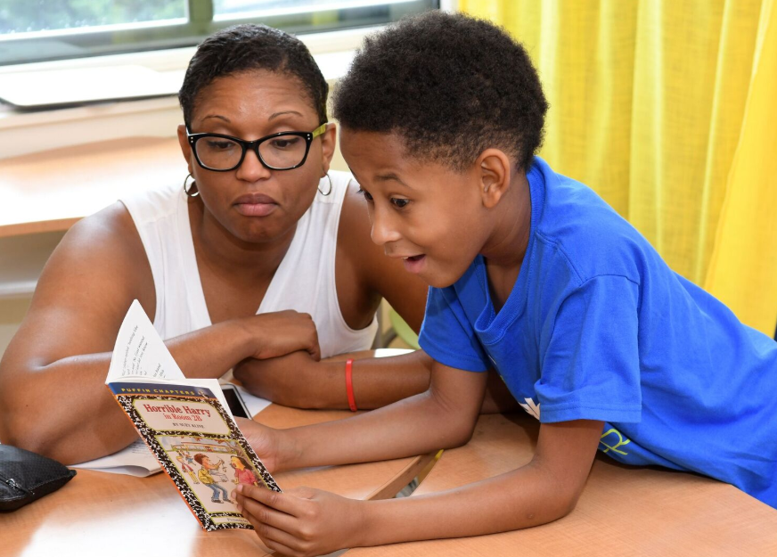

**To reserve your place in Springboard, fill out an enrollment form today!**

**We are looking forward to reading with you!**