**What is Springboard Connect?** 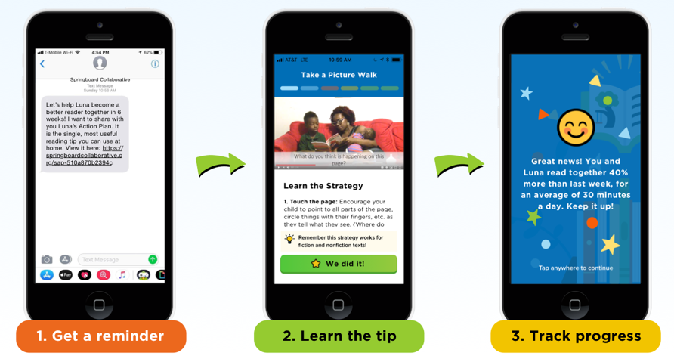

Springboard Connect provides free reading tips and resources to make reading at home fun and easy!  
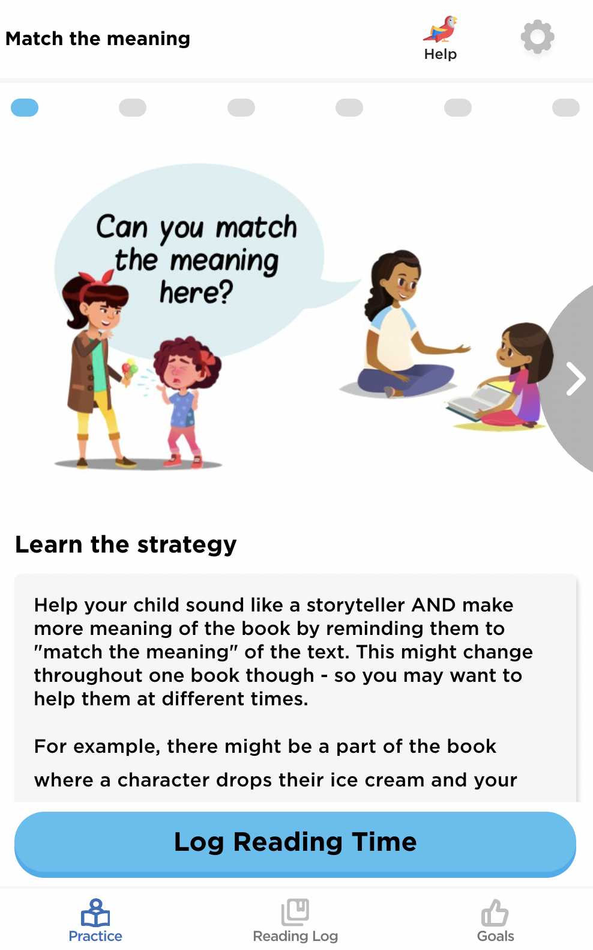

Through regular text message reminders, Springboard Connect:

* Supports families of young readers in building lasting reading habits together.
* Shares joyful and effective strategies, reminds you to read together with your kid, and tracks reading progress.
* Provides specific reading tips based on a teacher’s recommendation.
* Links to a landing page with learning materials.
* Offers content—in English and Spanish—created by Springboard’s literacy experts.

**How does Springboard Connect work?**

1. ***Get a reminder:*** Receive a series of text reminders with a link to open the selected reading strategy on your phone’s web browser. No sign-in is required. You can opt out of *Connect* anytime by replying STOP.
2. ***Practice the tip:*** Learn strategies and practice reading together with your child using the recommended reading tips. Every new tip builds on what your child has been practicing in the previous weeks and during the Springboard program.
3. ***Track progress:*** Share your child’s progress and the number of minutes they read. This lets the teacher know if your child is on track or needs more support.

**Why should I use it?**

Reading growth is a journey, not a destination! Research has shown that students who read at least 15 minutes a day and focus on improving targeted reading skills see reading gains higher than the national average. To help achieve this goal, Springboard Connect sends text reminders along with effective and joyful reading tips.

**Who do I reach out for support?**

If you have trouble using the tool, you can text your questions or issues to **37572** or simply reply to the texts. Our staff will reply to your requests as soon as possible.

**How will we use the data I provide?**

We only use the information you provided to help us improve Springboard Connect services. Occasionally, we may share anonymous data with your child’s school to demonstrate Springboard Connect’s impact on reading habits. Our staff may occasionally communicate with you and send surveys related to our tools and services via text messages.